Database Project - Milestone 2
NASA Exoplanet Explorer — ERD Design & Normalization
Members: Areeba Ali & Syeda Shandana Shah
Program: BS Artificial Intelligence
Semester: 4th (B)
Instructor: Sir Ali Hasan

Milestone | Date | Version | Remarks
ERD Diagram & Schema | 25 April 2026 | 1.0 | Flowchart
Normalization (M2) | May 2026 | 2.0 | 3NF normalization applied; ERD updated

Step 1 — Apply Normalization

Table 1: Exoplanet
Columns: planet_id (PK), pl_name, star_id (FK), method_id (FK), disc_year, pl_orbper, pl_radj, pl_bmassj, pl_eqt

NF | Status | Issue Found | Action / Justification
1NF | ✔ PASS | No repeating groups or multi-valued attributes. Every column stores exactly one atomic value per row. planet_id is the unique row identifier. | No change needed. Each cell holds a single value and the table has a clear primary key — 1NF is satisfied.
2NF | ✔ PASS | The primary key is a single column (planet_id). With a single-column PK, partial dependency is mathematically impossible — every non-key column must depend on the whole key. | No change needed. All columns (pl_name, star_id, disc_year, etc.) describe the planet and depend entirely on planet_id.
3NF | ✔ PASS | No non-key column determines another non-key column. star_id and method_id are foreign keys — they do not store star or method data inside this table. Those facts live in HostStar and DiscoveryMethod respectively. | No change needed. No transitive dependency exists. The schema was already designed to push repeating data into lookup tables.

Table 2: HostStar
Columns: star_id (PK), hostname, st_teff, st_rad, st_mass, st_dist, star_type

NF | Status | Issue Found | Action / Justification
1NF | ✔ PASS | All columns are atomic. hostname is a single star name. st_teff, st_rad, st_mass, st_dist are single numeric values. star_type is a single string. star_id uniquely identifies each row. | No change needed. Table satisfies 1NF.
2NF | ✔ PASS | Single-column PK (star_id). Every attribute — hostname, st_teff, st_rad, st_mass, st_dist, star_type — fully depends on star_id. Partial dependency is impossible. | No change needed. Table satisfies 2NF.
3NF | ✔ PASS | No transitive dependencies. star_type does not determine any other attribute. All physical measurements (st_teff, st_rad, st_mass, st_dist) are direct properties of the star identified by star_id. | No change needed. Table satisfies 3NF.

Table 3: DiscoveryMethod
Columns: method_id (PK), method_name, description

NF | Status | Issue Found | Action / Justification
1NF | ✔ PASS | method_name holds one string (e.g. 'Transit'). description holds one text block. method_id is the unique identifier. No repeating groups. | No change needed. Table satisfies 1NF.
2NF | ✔ PASS | Single-column PK. Both method_name and description fully depend on method_id. | No change needed. Table satisfies 2NF.
3NF | ✔ PASS | Only three columns. description describes the discovery method — it does not depend on method_name. No transitive dependency chain exists. | No change needed. Table satisfies 3NF.

Table 4: BlackHole
Columns: bh_id (PK), bh_name, bh_type, mass_solar, galaxy_id (FK), dist_ly, discovered

NF | Status | Issue Found | Action / Justification
1NF | ✔ PASS | All columns are atomic. bh_type stores a single string value ('Stellar' or 'Supermassive'). No multi-valued or composite attributes exist. bh_id uniquely identifies each row. | No change needed. Table satisfies 1NF.
2NF | ✔ PASS | Single-column PK (bh_id). All attributes describe the black hole directly and depend fully on bh_id. | No change needed. Table satisfies 2NF.
3NF | ✔ PASS | galaxy_id is a foreign key — it points to the Galaxy table rather than storing galaxy name or type here. All other columns (bh_name, bh_type, mass_solar, dist_ly, discovered) describe the black hole directly with no transitive chain. | No change needed. Table satisfies 3NF.

Table 5: Galaxy
Columns: galaxy_id (PK), galaxy_name, galaxy_type, dist_mly, stars, diameter_ly, bhs, exoplanets

NF | Status | Issue Found | Action / Justification
1NF | ✔ PASS | All attributes are atomic. stars stores one text estimate string (e.g. '200-400B') — a single indivisible display value, not a list. galaxy_id uniquely identifies each row. | No change needed. Table satisfies 1NF.
2NF | ✔ PASS | Single-column PK (galaxy_id). All attributes depend fully on galaxy_id. | No change needed. Table satisfies 2NF.
3NF | ✔ PASS | Potential concern noted: bhs and exoplanets could be derived by counting rows in BlackHole and Exoplanet tables. However, these are pre-aggregated NASA archive values stored as static galaxy attributes — not computed from another non-key column inside this table. No transitive dependency through a non-key column exists. | No change needed. bhs and exoplanets are accepted as direct galaxy attributes. Table satisfies 3NF.

Table 6: UserNotes
Columns: note_id (PK), object_type (ENUM), object_id, note_text, is_favorite, created_at

NF | Status | Issue Found | Action / Justification
1NF | ✔ PASS | Every column holds one atomic value. object_type holds a single ENUM value. note_text holds one annotation. is_favorite holds one boolean. note_id uniquely identifies each row. | No change needed. Table satisfies 1NF.
2NF | ✔ PASS | Single-column PK (note_id). All attributes — object_type, object_id, note_text, is_favorite, created_at — depend fully on note_id. | No change needed. Table satisfies 2NF.
3NF | ✔ PASS | object_type and object_id together form a polymorphic FK reference to identify which object is annotated. They are input values stored per note — they do not determine note_text, is_favorite, or created_at. All columns depend on note_id only. | No change needed. Table satisfies 3NF.

Step 2 — Remove Duplicates

Table | Checked For | Finding | Action Taken
Exoplanet | Star name, method name repeated across rows | star_id and method_id are FK references — no raw text is repeated in this table | No change. HostStar and DiscoveryMethod already act as lookup tables.
HostStar | Duplicate star records | hostname has a UNIQUE constraint — duplicate stars cannot be inserted | No change. Constraint already prevents duplicates.
DiscoveryMethod | Duplicate method names | method_name has a UNIQUE constraint — no duplicates possible | No change. Constraint already prevents duplicates.
BlackHole | Galaxy name repeated per black hole row | galaxy_id is a FK to Galaxy — galaxy name is not stored here | No change. Galaxy data lives in its own table, avoiding repetition.
Galaxy | bhs and exoplanets duplicating data in other tables | These are pre-aggregated count fields sourced from the NASA archive, not derived in real-time from other tables | Accepted as static attributes. No restructuring needed.
UserNotes | Separate tables per object type considered | A single polymorphic table using object_type ENUM is cleaner than three separate note tables | No change. Polymorphic design avoids structural duplication across three tables.

Conclusion: No columns were removed or restructured. The schema was already well-designed — repeating data had been separated into lookup tables (HostStar, DiscoveryMethod, Galaxy) and foreign keys were used throughout to avoid embedding redundant values.

Step 3 — Updated ERD Diagram
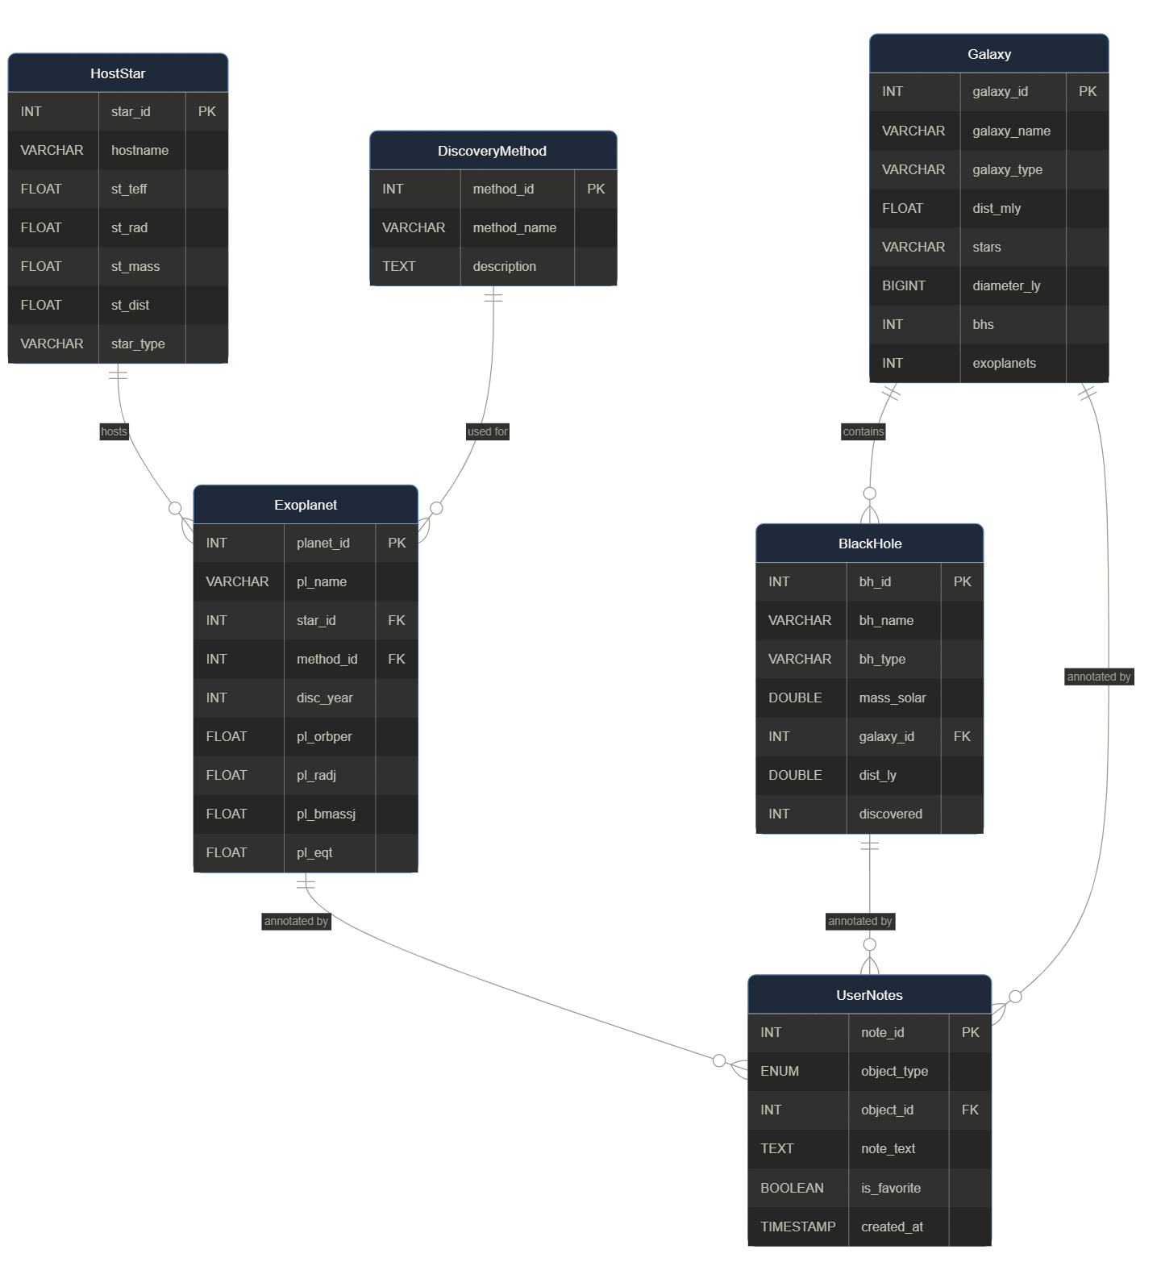

Relationships Summary
Relationship | Cardinality | Description
HostStar → Exoplanet | 1 : M | One star can host many exoplanets
DiscoveryMethod → Exoplanet | 1 : M | One discovery method can apply to many exoplanets
Galaxy → BlackHole | 1 : M | One galaxy can contain many black holes
Exoplanet → UserNotes | 1 : M | One exoplanet can have many user notes / favourites
BlackHole → UserNotes | 1 : M | One black hole can have many user notes / favourites
Galaxy → UserNotes | 1 : M | One galaxy can have many user notes / favourites

